**Computer Networks Lab: Network Traffic Analysis Report**

1. **Most active Protocol**

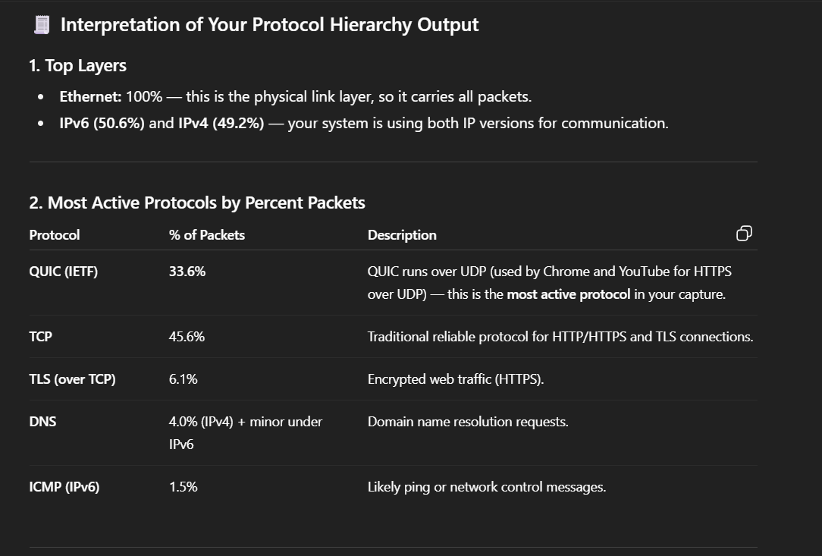

1. **unusual behaviour**

Some TCP retransmissions were observed, which likely resulted from temporary network delay or packet loss rather than malicious behavior.”

**failed connections**

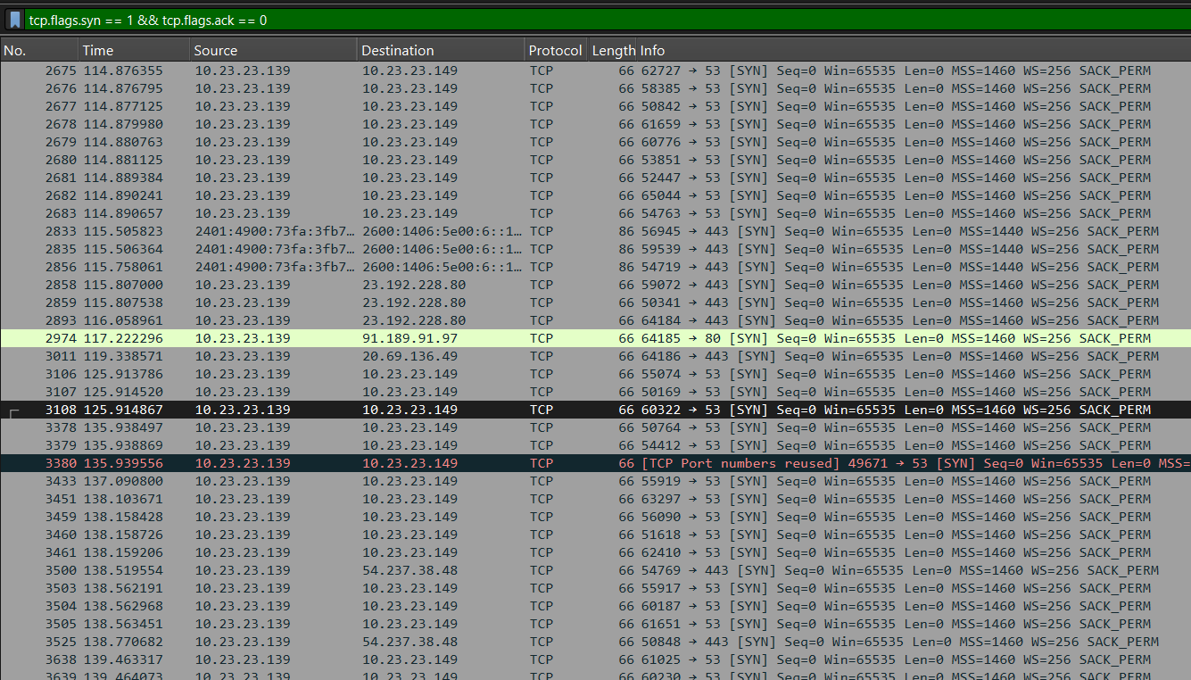

**Network congestion**

**Failed dns queries**

1. **KEY INSIGHTS**

The captured packets show that the system primarily communicates using encrypted web protocols (TLS over TCP and QUIC over UDP). DNS queries precede every HTTPS connection, reflecting typical web-browsing behaviour. Most traffic was outgoing from the local IP 10.23.23.139, confirming it as the client. A few retransmissions were noted, suggesting temporary latency but no packet loss or attack pattern